Parcel 332A

R12429 Mackinaw Rd, Town of Perrysburg

|  |  |  |  |
| --- | --- | --- | --- |
| *No Photo Available* | | **Status:** | Active |
| **Roll Section:** | Taxable |
| **Swis:** | 047000 |
| **Tax Map ID #:** | 7.002-1-23.3 |
| **Property Class:** | 322 - Rural vac>10 |
| **Site:** | RES 1 |
| **In Ag. District:** | No |
| **Site Property Class:** | 322 - Rural vac>10 |
| **Zoning Code:** | - |
| **Neighborhood Code:** | 70150 |
| **Total Acreage/Size:** | 22.35 | **School District:** | Gowanda |
| **Land Assessment:** | 2017 - $8,900 | **Total Assessment:** | 2017 - $8,900 |
| **Full Market Value:**  LANDLOCKED | 2017 - $13,485 |  |  |

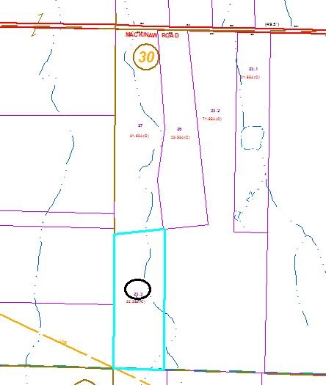

Approximate Yearly Taxes

School $228

Town/County $241

Total $469

Special Districts for 2015