Parcel 329

11427 Dewey Rd, Town of Perrysburg

|  |  |  |  |  |  |  |  |  |
| --- | --- | --- | --- | --- | --- | --- | --- | --- |
| http://maps.cattco.org/imate/quickstream.aspx?file=VOLLOCAL/Rel2017/047000016002000104000400000003.jpg&thumb=true&width=201&height=152 | | | **Status:** | | | Active | | |
| **Roll Section:** | | | Taxable | | |
| **Swis:** | | | 047000 | | |
| **Tax Map ID #:** | | | 16.002-1-40.4 | | |
| **Property Class:** | | | 270 – Mfg. housing | | |
| **Site:** | | | RES 1 | | |
| **In Ag. District:** | | | No | | |
| **Site Property Class:** | | | 270 – Mfg. housing | | |
| **Zoning Code:** | | | SR20 | | |
| **Neighborhood Code:** | | | 70350 | | |
| **Total Acreage/Size:** | 155 x 270 | | **School District:** | | | Gowanda | | |
| **Land Assessment:** | 2017 - $4,600 | | **Total Assessment:** | | | 2017 - $20,900 | | |
| **Full Market Value:** | 2017 - $31,667 | |  | | |  | |
| **Structure** | **Size** | **Grade** | | **Condition** | **Year** | |
| Mobile home wood addition | 16 × 32 | Economy | | Fair | 1996 | |
| Mobile home | 60 × 12 | Economy | | Fair | 1970 | |
| Pool-above ground | 4 × 48 | Average | | Normal | 2005  Approximate Yearly Taxes  School $535  Town/County $565  Total $1,100 | |

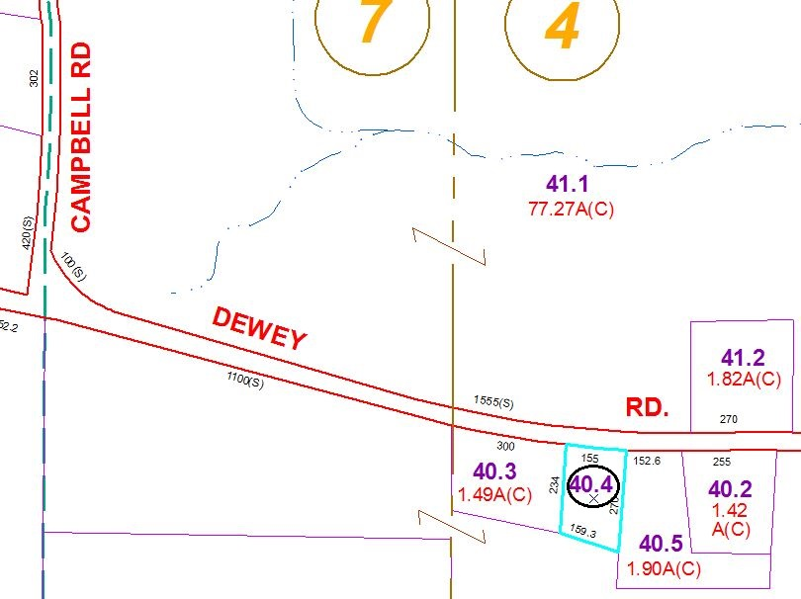

Special Districts for 2015