Parcel 285

 4566 Allegany Rd, Town of Napoli

|  |  |  |  |  |  |  |  |  |  |
| --- | --- | --- | --- | --- | --- | --- | --- | --- | --- |
| http://maps.cattco.org/imate/quickstream.aspx?file=VOLLOCAL/Rel2017/046200062003000103500100000013.jpg&thumb=true&width=201&height=152 | | | | **Status:** | | | Active | | |
| **Roll Section:** | | | Taxable | | |
| **Swis:** | | | 046200 | | |
| **Tax Map ID #:** | | | 62.003-1-35.1 | | |
| **Property Class:** | | | 270 – Mfg. housing | | |
| **Site:** | | | RES 1 | | |
| **In Ag. District:** | | | No | | |
| **Site Property Class:** | | | 270 – Mfg. housing | | |
| **Zoning Code:** | | | - | | |
| **Neighborhood Code:** | | | 62020 | | |
| **Total Acreage/Size:** | | 111 x 209 | | **School District:** | | | Randolph | | |
| **Land Assessment:** | | 2017 - $3,600 | | **Total Assessment:** | | | 2017 - $20,000 | | |
| **Full Market Value:** | | 2017 - $21,277 | |  | | |  | |
| **Structure** | **Size** | | **Grade** | | **Condition** | **Year** | |
| Mobile home | 66 × 14 | | Minimum | | Poor | 1988 | |

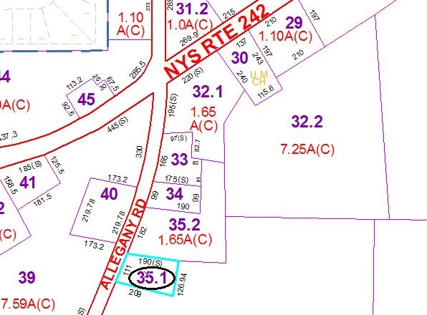

Approximate Yearly Taxes

School $203

Town/County $413

Total $616

Special Districts for 2015